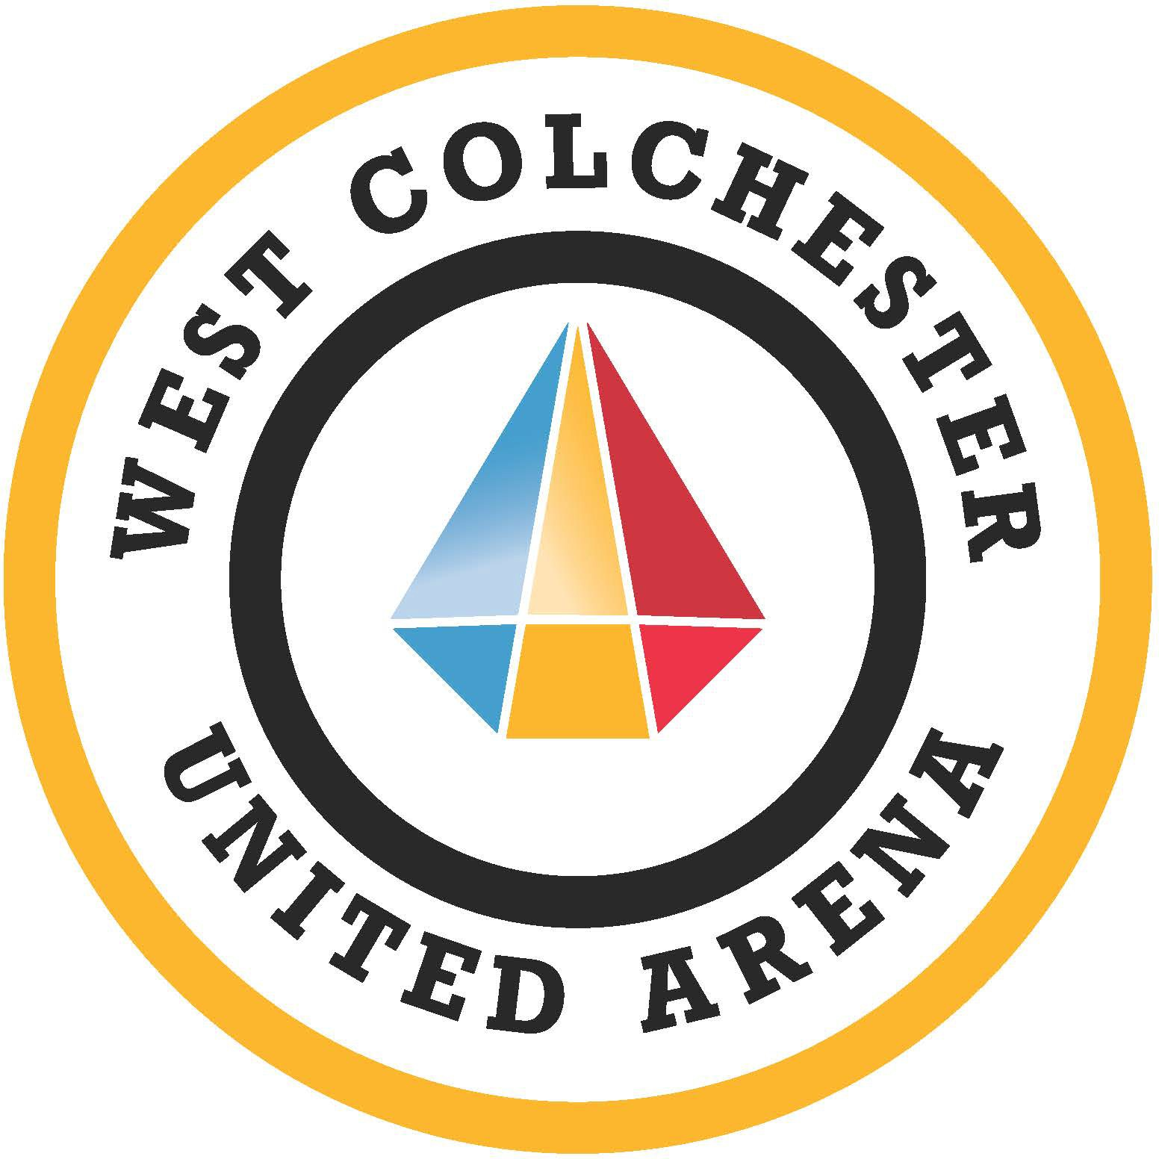

West Colchester United Arena
COVID–19 Screening Form For Family Skate & Sticks & Pucks
(to be completed prior to entering the Arena)
- In the past 48 hours have you had, or are you currently experiencing any of these symptoms?

Fever (i.e Chills and/or sweats OR Cough (New or worsening)
Yes No

OR two or more of the following symptoms (New or worsening)

Sore throat

Runny Nose/ nasal congestion Headache
Shortness of breath
Yes No

Yes No

Yes No

Yes No

- Have you travelled outside of the Atlantic Provinces/Canada or had close contact with anyone that has travelled outside of Atlantic Provinces/Canada in the past 14 days?
Yes No

Participants Name(s): ________________________

Signature: (Parent/Guardian Signature if under 18)
Phone Number (Contact):___________________________

